“Advanced JUnit Testing Exercises”
Exercise 1: Parameterized Tests Scenario: You want to test a method that checks if a number is even. Instead of writing multiple test cases, you will use parameterized tests to run the same test with different inputs.
SOLUTION:
1.EvenChecker.java
package Utilities;
public class EvenChecker {
public static boolean isEven(int number) {
return number % 2 == 0;
}
}
2.EvenCheckerTest.java
package Utilities;
import org.junit.jupiter.params.ParameterizedTest;
import org.junit.jupiter.params.provider.ValueSource;
import static org.junit.jupiter.api.Assertions.*;
public class EvenCheckerTest {
// ✅ Test with even numbers
@ParameterizedTest
@ValueSource(ints = {2, 4, 6, 8, 10, 100})
void testIsEvenWithEvenNumbers(int number) {
assertTrue(EvenChecker.isEven(number), number + " should be even");
}
// ✅ Test with odd numbers
@ParameterizedTest
@ValueSource(ints = {1, 3, 5, 7, 9, 99})
void testIsEvenWithOddNumbers(int number) {
assertFalse(EvenChecker.isEven(number), number + " should be odd");
}
}
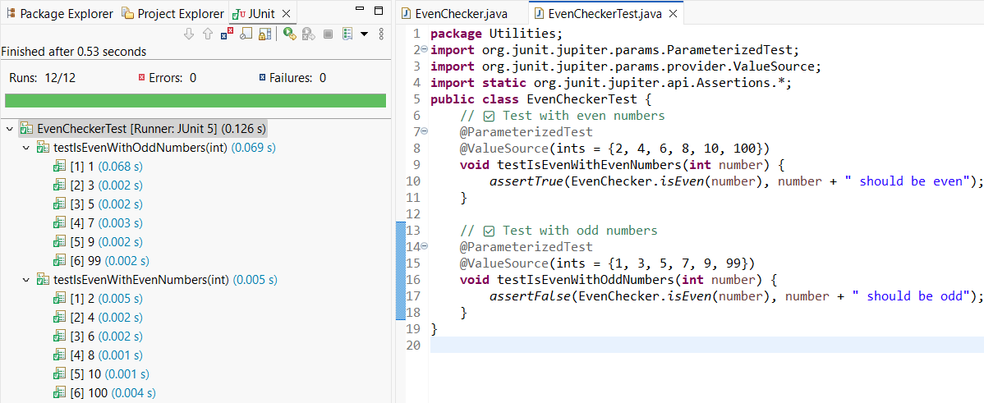
---------------------------------------------------------------------------------------------------------------------------
Exercise 2: Test Suites and Categories , Scenario: You want to group related tests into a test suite and categorize them.
SOLUTION:
1.MathTest.java
package Utilities;
import org.junit.jupiter.api.Test;
import static org.junit.jupiter.api.Assertions.*;
public class MathTest {
@Test
void testAdd() {
assertEquals(5, 2 + 3);
}
@Test
void testSubtract() {
assertEquals(1, 4 - 3);
}
}

2.StringTest.java
package Utilities;
import org.junit.jupiter.api.Test;
import static org.junit.jupiter.api.Assertions.*;
public class StringTest {
@Test
void testUpperCase() {
assertEquals("HELLO", "hello".toUpperCase());
}
@Test
void testLength() {
assertEquals(4, "test".length());
}
}
3.AllTests.java
package Utilities;
import org.junit.platform.suite.api.SelectClasses;
import org.junit.platform.suite.api.Suite;
@Suite
@SelectClasses({
MathTest.class,
StringTest.class
})
public class AllTests {
// No code needed; this class acts as a suite holder
}

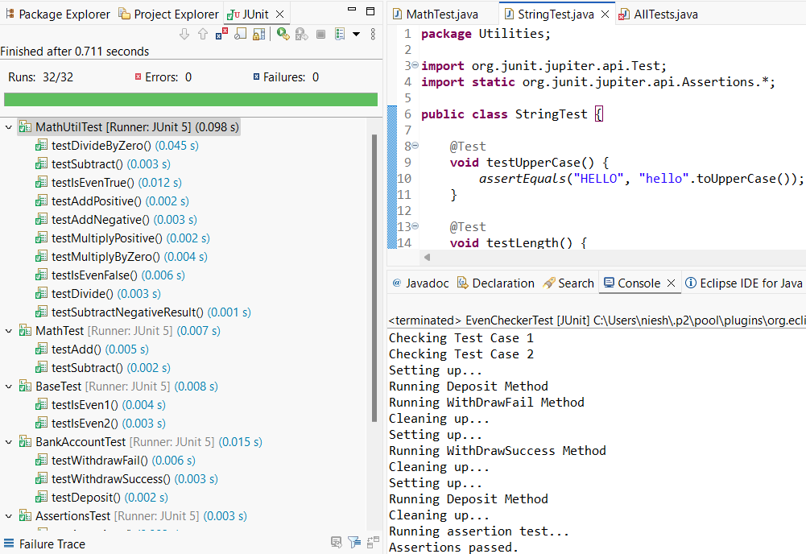
---------------------------------------------------------------------------------------------------------------------------
Exercise 3: Test Execution Order Scenario: You want to control the order in which tests are executed.
SOLUTION:
1.OrderedTests.java
package Utilities;
import org.junit.jupiter.api.*;
import static org.junit.jupiter.api.Assertions.*;
@TestMethodOrder(MethodOrderer.OrderAnnotation.class) // Enables @Order
public class OrderedTests {
@Test
@Order(1)
void testInitialize() {
System.out.println("Test 1 - Initialization");
assertTrue(true);
}
@Test
@Order(2)
void testProcessData() {
System.out.println("Test 2 - Processing Data");
assertEquals(10, 5 + 5);
}

@Test
@Order(3)
void testCleanup() {
System.out.println("Test 3 - Cleanup");
assertNotNull("done");
}
}
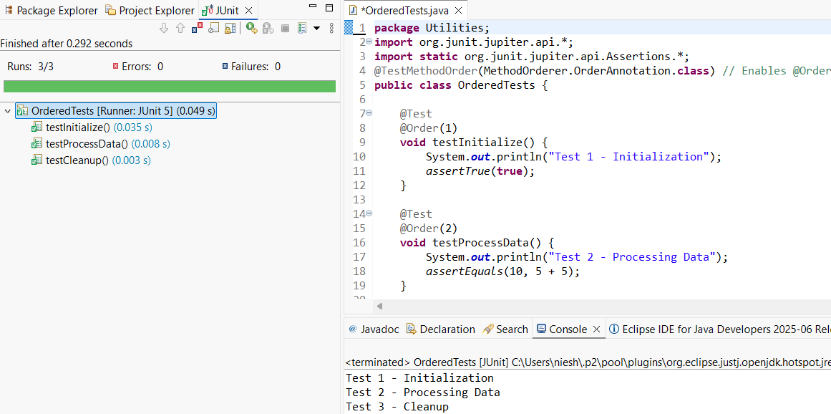

----------------------------------------------------------------------------------------------------------------

Exercise 4: Exception Testing Scenario: You want to test that a method throws the expected exception.
SOLUTION:
1.ExceptionThrower.java
package Utilities;
public class ExceptionThrower {
public void throwException(String input) {
if (input == null || input.isEmpty()) {
throw new IllegalArgumentException("Input cannot be null or empty");
}
System.out.println("Input is: " + input);
}
}
2.ExceptionThrowerTest.java
package Utilities;
import org.junit.jupiter.api.Test;
import static org.junit.jupiter.api.Assertions.*;
public class ExceptionThrowerTest {
@Test
void testThrowsExceptionForNull() {
ExceptionThrower et = new ExceptionThrower();
// Test for null input
assertThrows(IllegalArgumentException.class, () -> {
et.throwException(null);
});
}
@Test
void testThrowsExceptionForEmptyString() {
ExceptionThrower et = new ExceptionThrower();
// Test for empty string
assertThrows(IllegalArgumentException.class, () -> {
et.throwException("");
});
}
@Test
void testValidInput() {
ExceptionThrower et = new ExceptionThrower();
// No exception should be thrown
assertDoesNotThrow(() -> {
et.throwException("Hello JUnit");
});
}
}
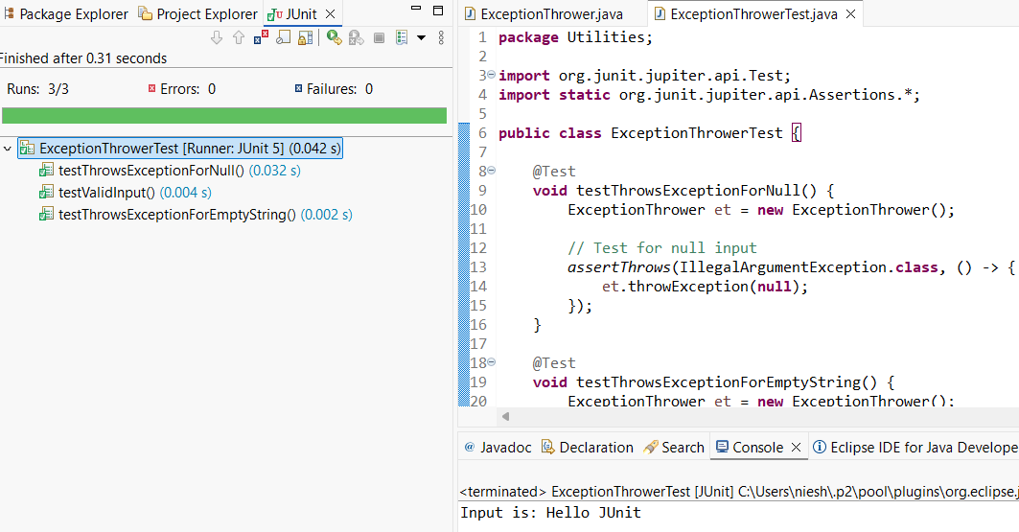

---------------------------------------------------------------------------------------------------------------------------

Exercise 5: Timeout and Performance Testing
Scenario: You want to ensure that a method completes within a specified time limit.

SOLUTION:
1.PerformanceTester.java
package Utilities;
public class PerformanceTester {
public void performTask() {
// Simulate a task that takes time
try {
Thread.sleep(300); // 300 milliseconds
} catch (InterruptedException e) {
Thread.currentThread().interrupt();
}
}
}
2.PerformanceTesterTest.java
package Utilities;
import org.junit.jupiter.api.Test;
import static org.junit.jupiter.api.Assertions.*;
public class PerformanceTesterTest {
@Test
void testPerformTaskWithinTimeout() {
PerformanceTester tester = new PerformanceTester();
// Assert that the task completes within 500 milliseconds
assertTimeout(
java.time.Duration.ofMillis(500),
tester::performTask,
"performTask() should complete within 500 milliseconds"
);
}
@Test
void testPerformTaskExceedsTimeout() {
PerformanceTester tester = new PerformanceTester();
// Example: force failure by expecting it within a shorter time (like 100ms)
assertThrows(AssertionError.class, () -> {
assertTimeout(
java.time.Duration.ofMillis(100),
tester::performTask,
"Expected to fail - performTask() should not complete within 100ms"
);
});
}
}



